U.S. Fish & Wildlife Service

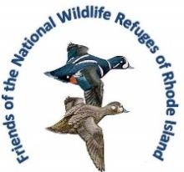
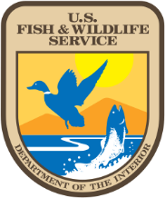
News Release
Rhode Island National Wildlife Refuge Complex
Block Island NWR Δ John H. Chafee NWR Δ Ninigret NWR Δ Sachuest Point NWR Δ Trustom Pond NWR
50 Bend Road, Charlestown, RI 02813 401/364-9124, Fax: 401/364-0170. Rhodeislandcomplex@fws.gov

Free Public Program
Wednesday, September 13, 2023 at 7 pm
Kettle Pond Visitor Center

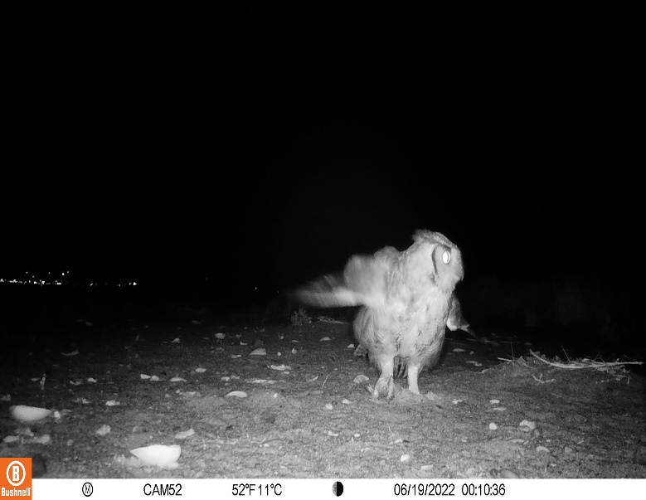
Tail Camera Videos With Elise Torello
Do you know who your wild furry and feathered neighbors are? Are you curious about what has been poking around in your compost, nibbling vegetation in your yard, or just passing through? One fun way to find out is to set up a trail camera and see what walks or flies by. You might be surprised how many animals visit when you're not looking, even if you don't live in the woods! The course will include: what features to look for when selecting a trail camera, what other gear you will need, selecting a location for your camera, and pointers for setting your camera up. You will also get to see fun videos of some of the amazing animals that have appeared on the instructor's cameras in South Kingstown.

Elise Torello is a two-time URI graduate, with degrees in Wildlife Biology and Computer Science. She has been employed by and volunteered with several local conservation organizations over the years, and currently serves on the Boards of Directors of the South Kingstown Land Trust and Friends of the Saugatucket. She is locally “famous” for her trail camera videos and usually has several cameras out in the nearby woods. What started as her hobby has become a source of enjoyment and connection with nature for friends, family, and community members who watch her videos online. Elise hopes to turn people into cheerleaders for nature and wildlife through her photography and videos. She and her husband live in South Kingstown with their two indoor cats, six hens, and lots of wildlife.
Wednesday, September 13, 7 pm
Kettle Pond Visitor Center, Charlestown RI
________________________

